Asian Shipbreakers An Environmental Time Bomb?

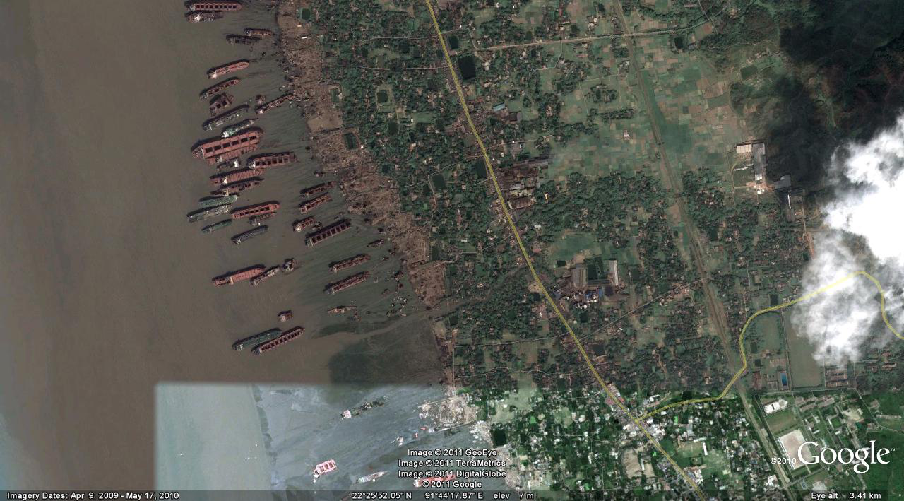
Chittagong, Bangladesh

Current shipbreaking is centred primarily in Pakistan, India, Bangladesh and China. Almost all vessels, with few exceptions, are broken up at beach facilities. Compared with standards or general norms expected within the industrialised countries, current methods of ship dismantling fail to comply in many aspects. Insufficiencies related to the adopted procedures include, but may not be limited to precautions, training and awareness and to facilities available. Furthermore, the implementation of measures for improvement will affect not only the ship-dismantling facility but may also raise issues relating to procedures prior to dismantling, as well as to the destiny of the waste or material streams derived from the extraction process. Problems generated by the insufficiencies of current ship-dismantling practices have consequences for not only the environment but also for the occupational safety and health of the workers.
By occupying and expanding the areas required for breaking, the dismantling industry affects both the local surrounding, environment and society. The established local community may be relying on basic industries such as fishery and agriculture; hence, conflict of interests may become an issue. Discharges and emissions to sea, ground and air cause both acute and long-term pollution. The lack of containment to prevent toxins from entering the environment is a major concern.
Toxins include the following:- Mercury, Arsenic, PCBs, Fuel oil, Refridgerants, Asbestos and many other petrochemical toxins.

The Following Is An Extract From The ILO Online Circa 2008

Proper ship breaking: a test for globalization and decent work

The last voyage of the ship 'Otapan' to a Turkish ship breaking yard last July was a victory for 'pre-cleaning' advocates of reducing the human and environmental dangers inherent in ship dismantling and recycling. However, does it also lead to decent working practices? Last week, experts from the ILO, the International Maritime Organization (IMO), and the Basel Convention met to discuss measures to promote guidelines that would make ship breaking not only clean but also 'green'. Questions and answers with a ship breaking expert from the ILO Sectoral Activities Branch.
Article | November 3, 2008
ILO Online: Environmentalists claimed a major victory when the ‘Otapan’ sails cleaned and decontaminated from Amsterdam to the Turkish ship breaking yards of Aliaga near Izmir. Can you tell us more about the ship’s odyssey?
David Seligson: The old chemical tanker had spent most of its nine last years in the Netherlands and was the subject of intense negotiations between the Dutch and Turkish governments and NGOs on pre-cleaning the vessel of all toxic substances before being dismantled. Following one aborted first attempt to dock in Turkey in 2006, the tanker’s ‘last voyage’ finally came to a happy ending last July as it sailed pre-cleaned to the ship breaking yards of Aliaga. ‘Pre-cleaned’ means that large quantities of hazardous substances such as asbestos and polychlorinated biphenyls (PCBs) had – as far as possible at this stage – already been removed in the Netherlands before the ship left for the ship breaking yards in Turkey.
What is the situation in these ship-breaking yards?
David Seligson: While breaking ships and selling of the scrap and hardware from retired vessels provides work and income for tens of thousands of persons in countries like Bangladesh, China, India, Pakistan and Turkey, the work is dangerous and deaths occur quite often as well as serious acute and chronic health problems. Titanic-sized vessels are floated ashore and cut up by workers who are often exposed to deadly toxins, exploding gases, falling steel plates and other dangers.
ILO Online: But isn’t ship breaking also a “green” industry?
David Seligson: Surely, if you look at the recycling aspect. To obtain 200,000 tons of iron ore from a mine, 1 million tons of soil has to be treated. Besides the impact of excavation activities on nature, three times more energy and water have to be used to obtain the iron. In addition, the national economy profits from ship dismantling and recycling activities as it does not have to import steel scrap. What’s more, the reusable parts of the dismantled ships, including machinery and equipments can be sold.
This does not mean that recycling jobs are always green. The recent ILO-UNEP-IOE-ITUC report finds that green jobs do not automatically constitute decent work. Many current recycling jobs, for instance, recover raw material and thus help to alleviate pressure on natural resources, but apply a process that is often dirty, dangerous and difficult, causing significant damage to the environment and to human health.
ILO Online: Ship breaking activities have almost entirely moved to South and Southeast Asia. What are the reasons?
David Seligson: Turkey is the only OECD member with significant ship breaking capacities, although its recycling activities represent only 2 per cent of the worldwide ship breaking market. Bangladesh, China, India, and Pakistan, the world's leading ship breakers, together hold a market share of 80 per cent. The shipyard owners estimate around 200,000 Bangladeshis benefit indirectly from this business conducted on their shores. In India, the biggest ship-breaking nation, the figure is half a million. Before, vessels were taken apart where they were built: in industrialized countries. However, high costs and environmental restrictions have driven ship owners to look elsewhere for a way of disposing these vessels. Countries in South Asia also have geographic conditions enabling the beaching of ships.
ILO Online: And the industry is likely to grow...
David Seligson: According to a study by BIMCO, the world’s largest private shipping organization, recycling capacities have been raised in the last years but will not cope with near future demand. Moreover, the price for recycled material is expected to go down. Along with these less attractive consequences for ship owners, health and safety efforts will have to be increased.
ILO Online: What can be done to make ship breaking decent work?
David Seligson: By decent work, we mean that the workers in the ship breaking yards receive a fair income, enjoy security in the workplace and social protection for their families; furthermore, they should have the freedom to express their concerns and to organize. There are a number of practical measures that can be taken, including providing, training for the workers, safety equipment and hygienic living quarters. We need a global partnership of ship owners, ship breakers, employers, trade unions and, of course, government inspectors who will see that these standards are enforced. This is yet again a test for globalization and decent work.
ILO Online: What is the role of the ILO?
David Seligson: Representatives of government, employers' and workers' organizations from heavyweight ship breaking nations Bangladesh, China, India, Pakistan and Turkey adopted ILO Guidelines on Safety and health in ship breaking: Guidelines for Asian countries and Turkey for the industry in 2004. As far as asbestos and other toxins present on the ships are concerned, the ILO provides various solutions based on its international standards, including ILO Conventions 139, 148, 162 and 170 on occupational cancer, working environment, safety in the use of asbestos.
The Basel Convention has also adopted Technical Guidelines for the environmentally sound management of the full and partial dismantling of ships, as well as other guidelines on the environmentally sound management of hazardous and other wastes.
What’s more, the International Maritime Organization (IMO) is preparing a convention on ship recycling to be adopted in 2009: the ILO has been contributing to the drafting process of this new instrument.
ILO Online: What are the next steps?
David Seligson: Being mindful of the “One UN” approach, and following the recommendations of the Joint Working Group, the Secretariats of the Basel Convention, IMO and ILO, drafted a concept for a “Global Programme for Sustainable Ship Recycling” to promote a coordinated approach in addressing the issues faced by the ship recycling industry.
The Global Programme is intended to establish a broad framework for activities to be undertaken in Participant countries with a view to facilitating future implementation of the “International Convention for the Safe and Environmentally Sound Recycling of Ships” and, prior to entry-into-force of the Convention, to promote the protection of human safety and health and the environment in the context of ship recycling activities.
The new IMO convention will be accompanied by a set of guidelines. A correspondence group has been established to prepare guidelines on ship recycling facilities as well as on an inventory of hazardous materials. We want to participate in this, in order to ensure that the new guidelines will be up to the standards and guidelines set by the ILO.
The Ship Breaking Yards of CHITTAGONG, BANGLADESH - YouTube
Top Ships Beaching Videos - YouTube
How $300 Million Cruise Ships Are Demolished | Big Business - YouTube
SHIPBREAKERS Documentary - YouTube
Ship Breakers | Bangladesh - YouTube
Where Ships and Workers Go to Die - YouTube This last link I believe, is the most suitable in terms of length and content but there is loads of this. There are about 6 of these sites doing this work in Greece, Turkey, Bangladesh, China and India.
See what you think of the vids etc. and if you want I’ll work on the script and notes.
Wee Jock

