

**Solid Materials: Wood: paper, textiles, fabric**



**Liquid/liquifiable solids: Petrol, Diesel Oils**



**Fires involving Gases: Butane, Methane, Propane**



**Cooking Oil (3+litres)**

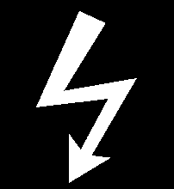

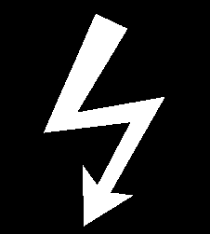

**Electrical Risk: Computers, Switchgear, Fax**

| **Extinguisher** | **Type of Fire to be used on** |
| --- | --- |
| **Water** |  |
| **FOAM** |  |
| **CO2** |  |

|  |  |
| --- | --- |
| **Extinguisher** | **Type of Fire to be used on** |
|  |  |
|  | **Dry Powder** |
| **Wet Chemical**  **Water with Additive** |  |