ACTIVITY 1: Introductions and aims

Refer to the Climate Change on Learn with Unite:

https://www.youtube.com/watch?v=cEGqOZMhQGg

ACTIVITY 2: The environment crisis: Challenge and
opportunity

Refer to the below and your own recognition agreements. There may be other pieces of legislation that you can think of:

Unite Health and Safety Guide – Chp.19: Environmental Issues at Work (P.152-153)
(See Appendix 1 – Chapter 19 Pages 152 to 154 of April 2018 edition)

Safety Reps, Safety Committees Regulations 1977
https://www.unitetheunion.org/media/1489/safety-reps-brown-book.pdf

Information and Consultation Regulations
https://www.unitelegalservices.org/media/1582/information-and-consultation-regulations-unite-guide-for- members.pdf

TUC guides to Health and Safety
https://www.tuc.org.uk/guides-and-reports-health-and-safety-reps

For Information Only

ACTIVITY 5: Mapping our supply chains

Refer to:

Transparency in Supply Chains etc. A practical guide
https://assets.publishing.service.gov.uk/government/uploads/system/uploads/attachment_data/file/6499 06/Transparency_in_Supply_Chains_A_Practical_Guide_2017.pdf

ACTIVITY 6: Understanding the Work Process
ACTIVITY 7: If we tolerate this

Refer to:

‘Greener workplaces for a just transition’ – Wales TUC Toolkit Section 4
https://www.tuc.org.uk/greener-workplaces-just-transition-wales-tuc-toolkit-trade-unionists

Section 4 (from page 168) of this document will be of particular use for Activity 7.
Please note that this resource may be useful for all activities.

ACTIVITY 8: The shovel ready magnificent seven
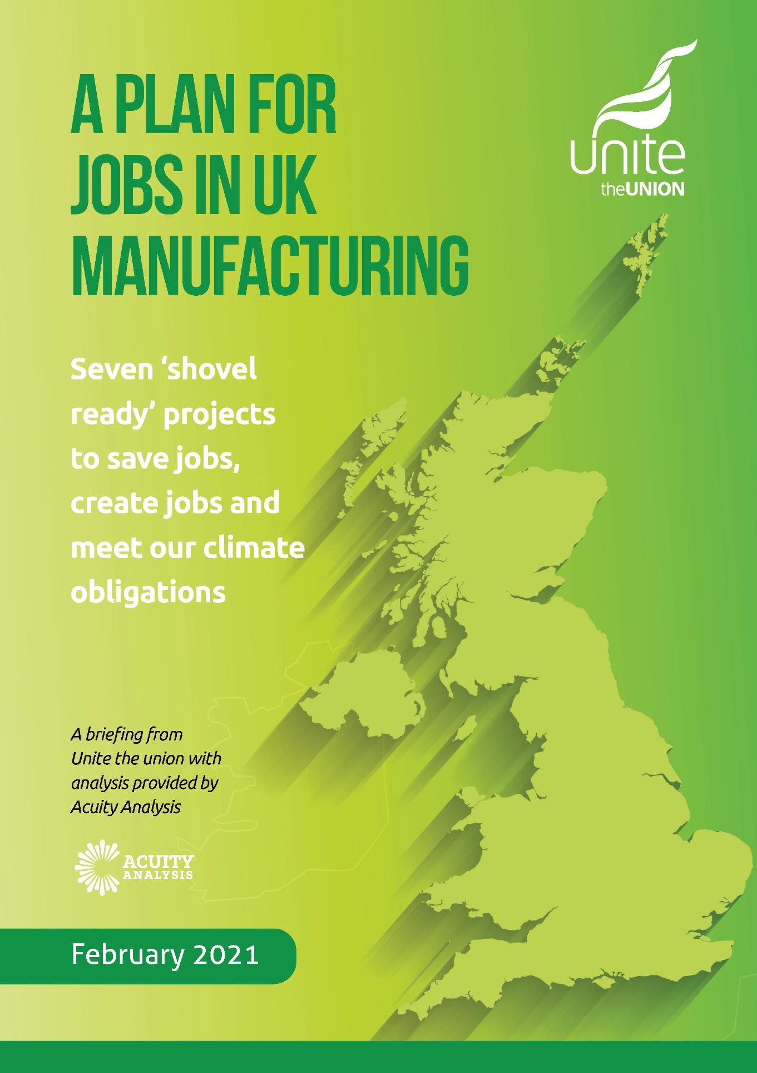

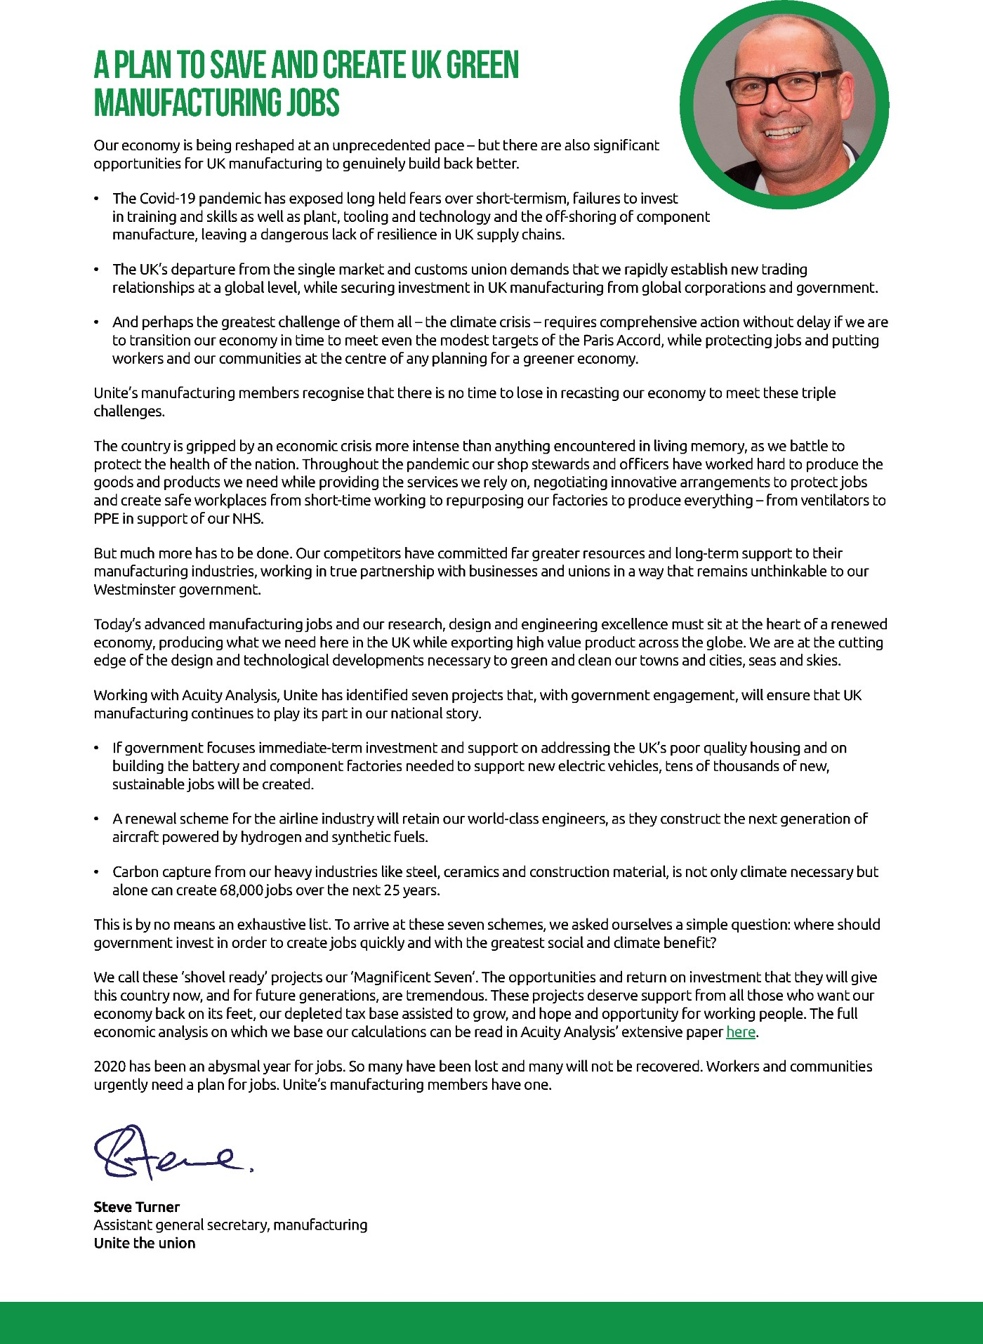

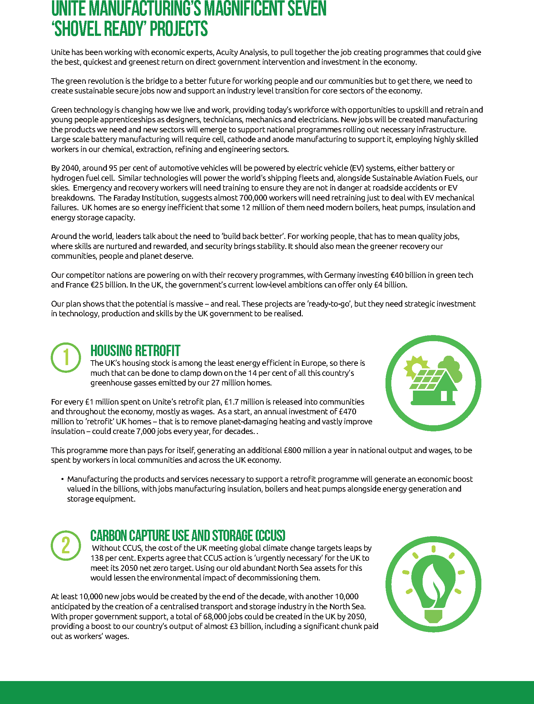

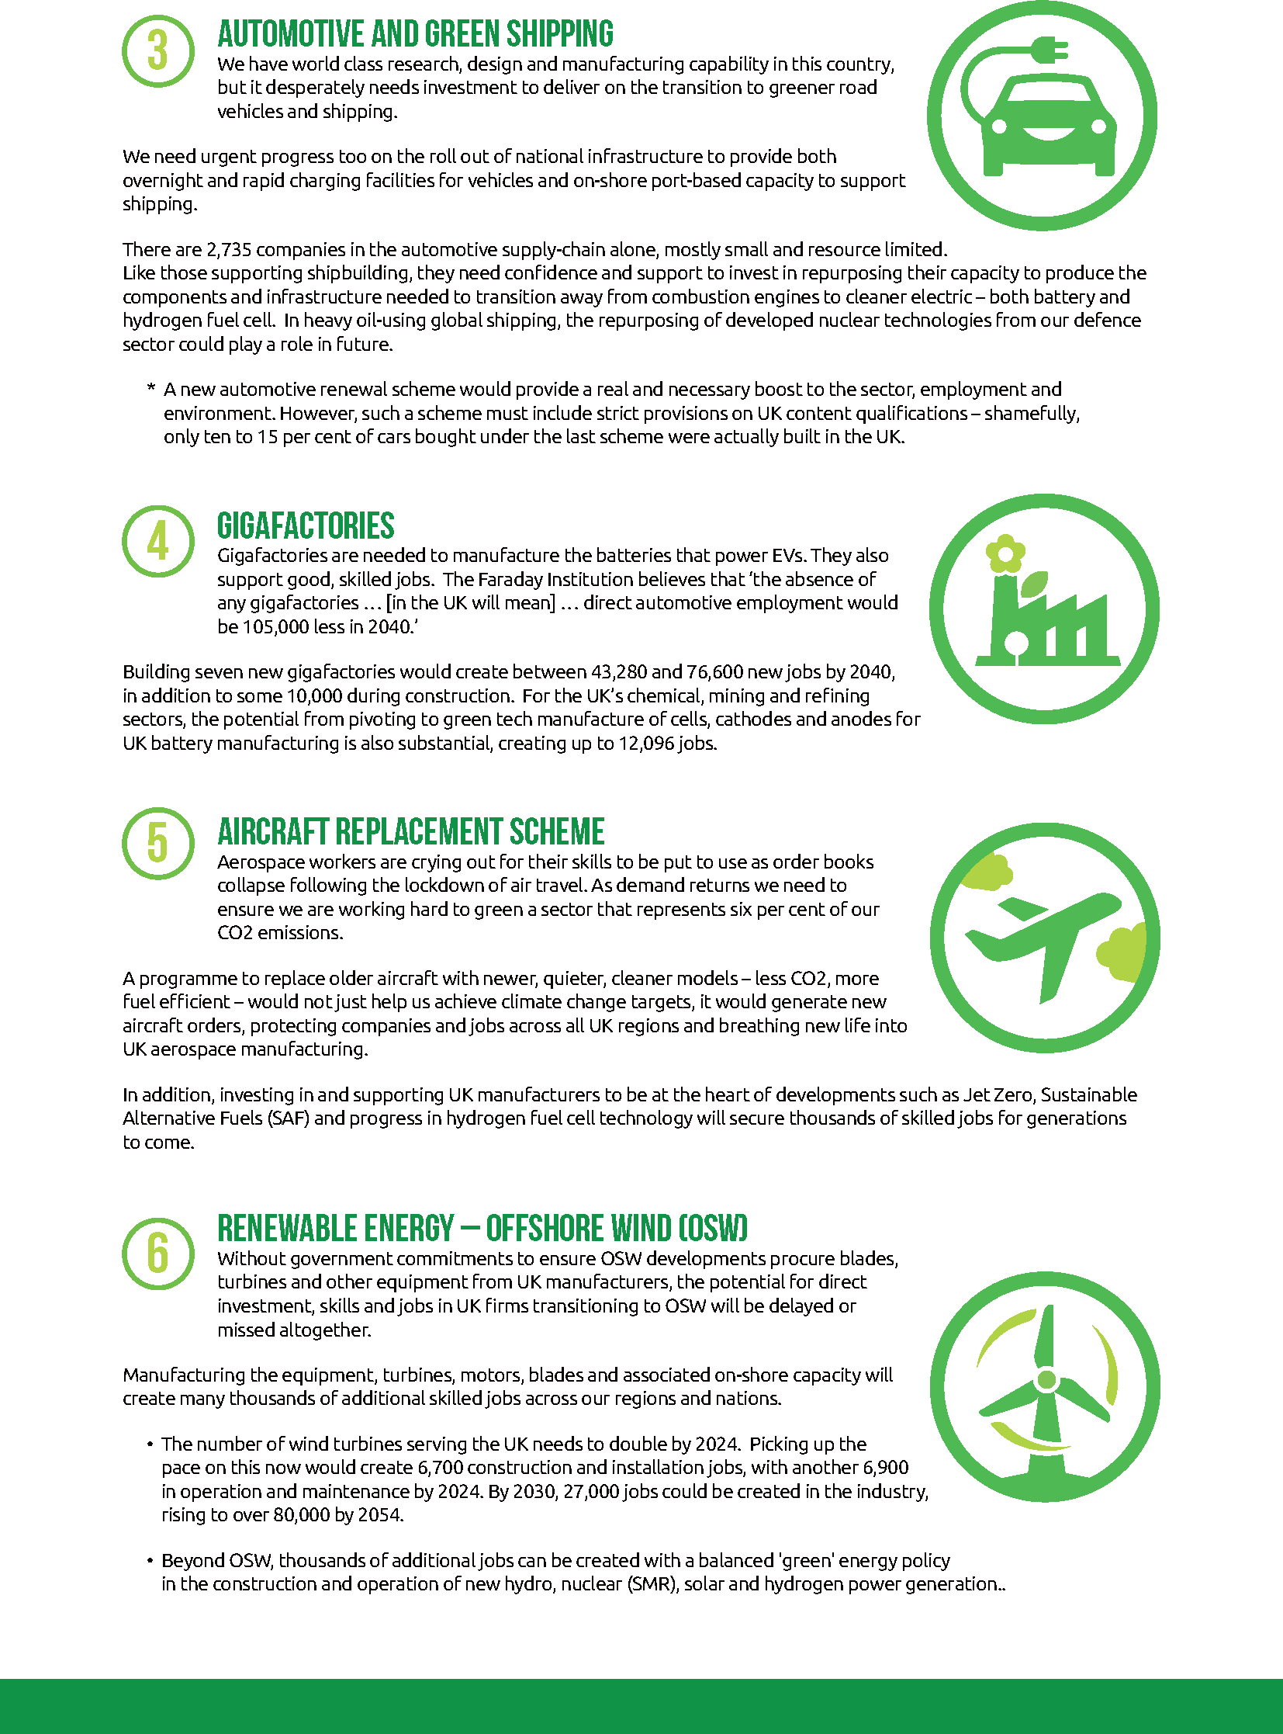

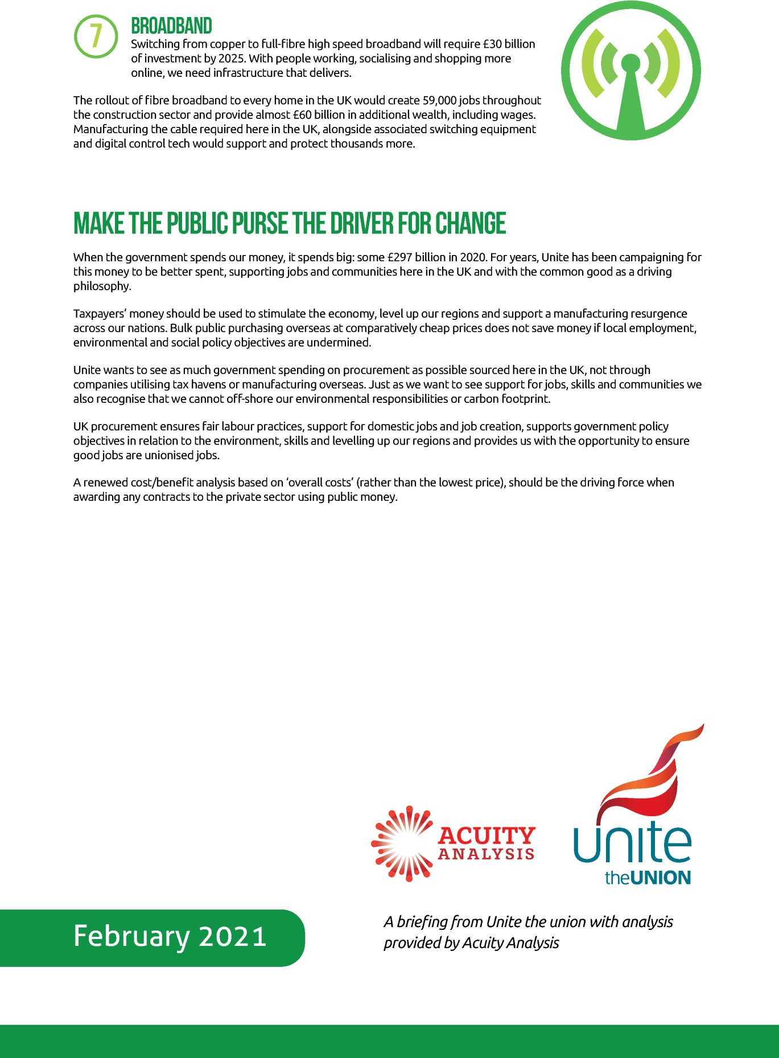

ACTIVITY 9: Waste not, want not

Refer to:

‘Greener workplaces for a just transition’ – Wales TUC Toolkit
https://www.tuc.org.uk/greener-workplaces-just-transition-wales-tuc-toolkit-trade-unionists

From page 92 - Resource efficiency – reduce, reuse, recycle.

ACTIVITY 10: Getting stuck in
Undertake a Google search, however you may also refer to:

HSE COSHH – A brief guide
www.hse.gov.uk/pubns/indg136.pdf

The following articles may be of interest:-

The Environmental Protection Act: https://www.legislation.gov.uk/ukpga/1990/43/contents

Waste Regulations 2011: https://www.legislation.gov.uk/uksi/2011/988/contents/made

COP26: https://ukcop26.org/

ACTIVITY 11: For I dipped into the future…
For further reading:
Florence Wildblood - Trade unions and green innovation: an (un)likely alliance?
https://www.maddyness.com/uk/2021/01/20/trade-unions-and-green-innovation-an-unlikely-alliance/

ACTIVITY 13: A COP26 out?

Your tutor will show three videos, namely: -

- Greta Thunberg – Blah, Blah, Blah

- Young activists demand more action at COP26

- STUC General Secretary addresses COP26 in Glasgow

These are all available in your online resource bank

ACTIVITY 15: Equality and the environment

Case Study A – Consumers and equality
Women in Britain and Ireland tend to be the primary carers for children, women also are more likely to find themselves in less secure forms of employment and on lower wages. Most single parent families consist of a woman and children in the family home, with that woman providing fir the everyday needs of the children, even if economic support may come from the fathers of the children.

This being the case women are often having to make the daily choices regarding food purchases and those choices will often be governed by available income and constraints in the household budget.

A mum may be heavily inclined to ensure that the children have a healthy diet which is environmentally friendly, plenty of locally harvested organic produce and less reliance of mass produced frozen and tinned fruit which may have travelled halfway around the world.

Parents also want to bring their children up to respect the planet and to learn at an early age, the importance of ethical and environmentally friendly consumption.

Case Study B – Hurricane Katrina
A disaster like a hurricane can exacerbate the factors that lead people to commit sexual assault, such as poverty, displacement, lack of housing, and lack of a police presence. A disaster can also put people in situations where they’re at greater risk of being assaulted, from living with an abusive family member to staying at a crowded shelter. A reliable count of sexual assaults during Hurricane Katrina which hit Louisiana in 2005 is hard to come by because the barriers to reporting assault — always high, even without a natural disaster looming — are even higher during a storm, when resources are stretched and law enforcement is focused on search and rescue.

Almost a third of sexual assaults reported during that storm and Hurricane Rita, which hit New Orleans a month later, took place at evacuation shelters, according to a survey by the National Sexual Violence Resource Centre. Shelters were the most common site of reported sexual violence. The most dangerous shelters tended to be those that were understaffed, or where staff were not trained in disaster relief, said Greg Forrester, the president of National Voluntary Organizations Active in Disaster. Overcrowding and chaotic shelter conditions can put evacuees at increased risk of sexual assault. So can inadequate lighting and an abundance of out-of-the-way areas where people can commit violence unobserved. The American Red Cross, which runs the majority of shelters in the Houston area, requires that each shelter have law enforcement present at all times, said Forrester. All Red Cross shelters also have safety officers who are trained to spot warning signs of sexual abuse and assault.

Trans people, especially BAEM trans people, face heightened suffering at all stages of the natural disasters which are becoming more frequent in our changing climate. During Katrina, trans people faced discrimination in emergency shelters, and some were even turned away due to their characteristic. Over a decade later, the Black gay community of New Orleans has still to fully recover. Homeless people are particularly vulnerable to the erratic weather events brought by climate change. In the UK, 24% of homeless youth are LGBTQ+. In Kingston, Jamaica, many ostracised LGBTQ+ young people live in makeshift

camps outside the city which can be flattened or flooded by hurricanes. LGBTQ+ are more likely to have trouble crossing borders to escape conflict and disaster.

Article amended from Vox article, Anna North.

Case Study C – Cumbria Floods
Heavy rainfall from Storm Desmond in 2015 - 2016 caused severe disruption due to unprecedented rainfall. Carlisle, Appleby, Keswick and Kendal amongst many other areas suffered power outages, collapsed bridges, homes evacuated and workplaces flooded or closed.

In Carlisle, production at the McVitie's biscuit factory was halted when flood waters entered the site early on December 6, when the site experienced 5 feet of floodwater which cause significant damage to the brick ovens, workers livelihoods and even product shortages on retail shelves. With support from Unite,
McVitie’s 600 workers were told to remain at home due to significant risks to their health, safety and
wellbeing.

The cost to Cumbria of Storm Desmond, the worst flooding in 600 years as far as the county was concerned, was estimated at over £500m. But as a report from the Carlisle Flood Action Group, pointed out, the damage is not just financial: “The human cost of the storm and its aftermath is similarly incalculable. The effect of evacuation and displacement on physical and mental health, with lives put on hold, was significant and remains so for many.”

McVitie’s has since erected flood gates and defences around their perimeter to protect the workplace and crucially, workers.

Flood victims more likely to suffer poor mental health, survey reveals
ITV News: Thursday 5 September 2019
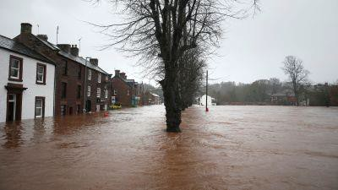

People whose homes have been damaged by storms and flooding are at greater risk of mental illness, according to a new study.

Research led by the University of York found that in flood-hit areas like Cumbria and southern Scotland those directly affected are 50% more likely to have mental health problems.

The university team and the National Centre for Social Research analysed more than 7,500 responses to the Adult Psychiatric Morbidity Survey in England.

For the first time, participants were asked whether their home had been damaged by extreme weather in the last six months.

During this time - December 2013 to March 2014 - the UK saw more than four million flood warnings and more than 10,000 properties were left underwater.

Analysts then looked into incidences of common mental health disorders (CMD), from depression and phobias, to anxiety and suicidal thoughts.

Their research found storm related damage was significantly associated with CMD, suicidal ideation and previous suicide attempts.

People were more likely to experience poor mental health even when the damage was relatively minor and they were not forced to leave their homes, the study suggested.

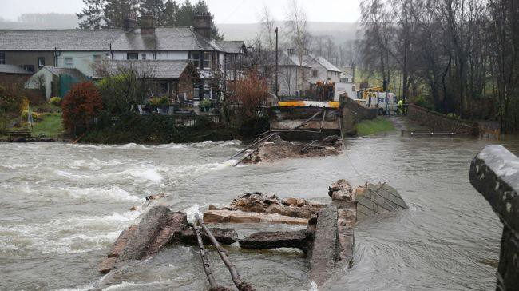
The clear up operation at Pooley Bridge after it was washed away by high water in December 2015.

"This is reflective of the huge impact storms and flooding have on people's lives as alongside the physical damage to homes and businesses, there is the emotional damage to the sense of security that many people derive from their home." - Professor Hilary Graham, from the department of health sciences at the University of York.

ACTIVITY 16: Out of time
Definition
The concept of a gap between the Global North and the Global South in terms of development and wealth.
The Brandt Line
Classifying countries
In the 1980s, the Brandt Line was developed as a way of showing the how the world was geographically split into relatively richer and poorer nations. According to this model:
- Richer countries are almost all located in the Northern Hemisphere, with the exception of Australia and New Zealand.
- Poorer countries are mostly located in tropical regions and in the Southern Hemisphere.
However over time it was realised that this view was too simplistic. Countries such as Argentina, Malaysia and Botswana all have above global average GDP (PPP) per capita, yet still appear in the ‘Global South’. Conversely, countries such as Ukraine appear to be now amongst a poorer set of countries by the same measure.
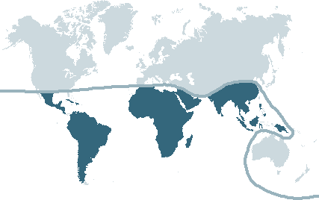
More developed countries
Less developed countries

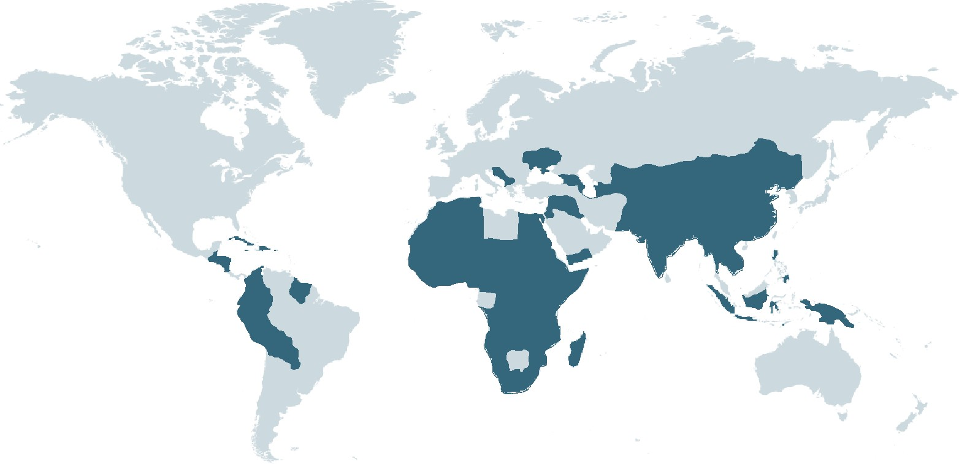
Countries with a GDP (PPP) per
capita <US$10,700 (shaded)

The gap between the ‘North’ and ‘South’
Despite very significant development gains globally which have raised many millions of people out of absolute poverty, there is substantial evidence that inequality between the world’s richest and poorest countries is widening. In 1820 western Europe's per capita income was three times bigger than Africa’s but by 2000 it was thirteen times as big. In addition, in 2013, Oxfam reported that the richest 85 people in the world owned the same amount of wealth as the poorest half of the world’s population.

Today the world is much more complex than the Brandt Line depicts as many poorer countries have experienced significant economic and social development. However, inequality within countries has also been growing and some commentators now talk of a ‘Global North’ and a ‘Global South’ referring respectively to richer or poorer communities which are found both within and between countries. For example, whilst India is still home to the largest concentration of poor people in a single nation it also has a very sizable middle class and a very rich elite.
There are many causes for these inequalities including the availability of natural resources; different levels of health and education; the nature of a country’s economy and its industrial sectors; international trading policies and access to markets; how countries are governed and international relationships between countries; conflict within and between countries; and a country’s vulnerability to natural hazards and climate change.

Also Refer to:

World Wildlife Fund - ‘Bees under siege from habitat loss, climate change and pesticides’

Available via the following link

https://www.wwf.org.uk/sites/default/files/2019-05/EofE%20bee%20report%202019%20FINAL_17MAY2019.pdf

Appendix 1 – Unite H&S Guide

Unite Health and Safety Guide – Chp.19: Environmental Issues at Work (P.152-153)
(Chapter 19 Pages 152 to 154 of April 2018 edition) Copied here but also available via the Unite Web Site

Chapter 19 Environment
The World’s climate is changing brought about by the actions of man since the dawn of the industrial revolution. Several years ago people thought that statement to be pure fantasy as we are talking about altering nature on an enormous scale and man has been burning fossil fuels and other materials for thousands of years. The effects of climate change are upon us and are very real. Even if we stopped emitting all greenhouse gasses today the inertia built up from all the emissions released since the industrial revolution will continue to change our world’s climate for the worst.
The effects of these changes will cause deserts to increase in size, annual rains to fail in tropical regions and the ice packs all over the world to decline. Population is solely reliant on ice melt from the glaciers of the high Himalayas which is in sharp decline year on year; Atlantic conveyor (part of the Gulf Stream) is slowing as a result of the ice melt from Greenland which is resulting in more erratic and extreme weather patterns hitting Europe and sea levels. We all need to think before we carry on as before.
Rising sea levels are widely considered to be the greatest threat posed by climate change. They threaten low-lying countries with inundation, forcing inhabitants to migrate. Coastal cities and ports could be flooded, as could cities sited near tidal estuaries, like London. Many nuclear installations are built by the sea so they can use sea water for cooling.
The potential for sea level rise is enormous. This is because the ice caps - Greenland and Antarctic - contain huge amounts of fresh water - around 70% of all the freshwater on Earth. Estimates suggest that if the Greenland ice sheet was to melt away to nothing, sea levels would rise around 6 metres. To put that a different way, a loss of just one per cent of the Greenland ice cap would result in a sea level rise of 6cm. If the West Antarctic Ice Sheet (WAIS) were to melt, this would add around 6 metres to sea levels. If the East Antarctic Ice Sheet (EAIS) were to melt as well, seas would rise by around 70 metres. And ice and snow reflects 90% of the suns energy, open water absorbs 90% of that energy so the loss of snow and ice increases the speed of global warming.
Sceptics point to the ice cube in a glass of water to claim that this is all rubbish as when ice in a glass melts the level of liquid does not change. This is true if we were only to consider the ice already in the sea such as that at the North Pole. But the Antarctic Ice Sheet is on land as are the glaciers of Greenland. The weight of all the ice on Antarctica and Greenland also supresses the land mass causing it to sit lower, than it would if there were no ice, as can be shown by the rebounding of land

masses that is still going on today following the last ice age in places like Scotland. As a result the land itself, in these areas, will over time rebound as well increasing sea levels still further.
The increasing risk of flooding, sea level changes and the reduction in fertile land can have only one result, increased migration of people from areas that are no longer productive into areas that can provide food and fresh clean water. The increase in population caused by not just migration but by general population increases will in time overwhelm the capacity of that land leading to famine and yet more migration. The net effect then causes increased tensions and wars over resources and the break down in civil society around the world. A sea level increase of 7 metres would mean that Cambridge, Peterborough and Doncaster would be on the coast, Glastonbury would be surrounded on three sides by water and Portsmouth would have been swept away by the sea .
This is why the vast 195 of the world 198 nations around the world agreed to sign up to the United Nations Framework Convention on Climate Change (UNFCCC) dealing with greenhouse gas emissions mitigation, adaptation and finance in 2015. This historic agreement showed that these nations felt that the amount of scientific evidence was now so overwhelming that they needed to make a change.
Every Little helps
Even a very small change can make a huge difference and in the world of work can be the difference between your employer making a profit or a loss, impacting on your job security. Working with employers we can make a difference and one which could also benefit employees financially. For if you and your colleagues are instrumental in reducing your employer’s bills then we would want to see at least some of that money utilised in rewarding staff for their efforts. It has also been shown that where you pick up money saving tips at work, they are carried over into the home.
But where to start? The first step is to consider what is being used and what is being thrown away and if there is a way to reduce waste. By meeting with your employer you may be able to discover the current size of their energy and water bills. This will give you a foundation to see how successful you are.
In a transport company, for example, a change in driving style will reduce the fuel bill for example. Even ensuring a vehicle has the correct tyre pressure can have a significant effect. Scientific studies, have determined that for every 1 bar of pressure of under inflation a vehicle will lose around 5.5% of its ultimate performance while over inflation will damage the tyre and will only make very marginal savings. A vehicle is designed to be at its most fuel efficient at between 45 mph and 55 mph (72.4 km/h to 88.5 km/h) and swift acceleration and breaking reduces fuel economy even further. The answer is simple keep the speed down, the tyres up and drive smoothly.

In an office: - switching off the lights in unoccupied rooms and using often the ambient light from outside is enough to work normally in an office environment. Where lighting is needed, then utilising LED’s instead of filament bulbs or even fluorescent tubes can make even greater savings. Reusing scraps of paper where ever possible and then recycling them can make an enormous difference as can the recycling of many other materials. Paper comprises 20-25% of municipal waste generated in Europe and once in landfill degrades producing methane a greenhouse gas estimated to be 25 – 30 times more powerful as a greenhouse gas than carbon dioxide. One ton of recycled office paper saves 4,100 Kwh of energy, 54 million Btu's of energy, 27.2 kgs of air pollutants from being released, 26,500 litres of water, and 2.5 m3 of landfill space .

Environmental Reps
Some safety rep will also be environmental reps. Environmental reps have no legal powers, but should use their safety rep rights to pursue environmental issues in the workplace and should negotiate an agreement that they will be recognised by their employer. It will often be the case that environmental issues and health and safety issues coincide.
Unite recognises the importance of environmental reps, with the position of environmental rep identified in the Unite rule book
“18.1 At each workplace, the members employed at that workplace, shall elect from amongst themselves, at least every 3 years, 1 or more of the following representatives:…
18.1.5 Environment representatives”
Safety Reps’ Signposts
TUC Resources on this can be found at :- https://www.tuc.org.uk/research-analysis/reports/greening-workplace-%E2%80%93-environmental-rights-work
Background on TUSDAC https://publications.parliament.uk/pa/cm200405/cmselect/cmenvaud/84/84we43.htm
This is the TUC page on TUSDAC https://www.tuc.org.uk/research-analysis/reports/trade-unions-and-sustainable-development
ITUC Climate Change News and resources:- https://www.ituc-csi.org/climate-change
TUDCN Strategy on the 2030 Agenda for Sustainable Development:- https://www.ituc-csi.org/IMG/pdf/tudcn_agenda_2030_strategy_nov_2017_en.pdf

