Unite national education
Activist training on public speaking

Overview
The purpose of this short course is to consider the communication skills required by Unite activists concentrating upon developing good public speaking techniques in order to support and represent our members, their families and communities effectively.
The course will deal with several aspects of communication as follows
- Looking at communication theory
- What can be done up front, preparation
- Speech construction
- Delivery techniques
- Practical exercises in public speaking
Looking at communication theory
We will examine some of the various models of effective communication and consider the value of each and the challenges of communicating effectively with people in a trade union and community context.
What can be done up front
We will look at the methods which can lead to better communications in terms of meetings, events, conferences etc concentrating on practical tips for ensuring good attendance and participation

Speech construction
We will consider how to construct an effective speech for a conference, event, meeting or interview, whatever the circumstances the construction is fairly standard and certain methods will lead to the likelihood of a more effective outcome.
Delivery techniques
There is no magical solution to delivering good quality speeches however there are some techniques which can lead to building confidence and reducing nerves in order that the outcome is likely to be more successful.
Practical public speaking
The second part of the course will concentrate on practising our public speaking techniques in a comfortable safe environment and crystallising the theoretical skills which we have discussed

SPEAKING IN PUBLIC

PREPARING YOUR SPEECH

- Be sure you know your subject.
- Decide on the key points you want to make – don’t try to include too many.
- Work out a structure for your speech – ie, beginning, middle and end.
- Make sure it is relevant to the group you are speaking to.
- Don’t write your speech out word for word, put down key words or headings.
- Try to have a strong ending.
- Use real examples.
- Practice if you want, but not too much or you will sound stale when you speak.
- Use humour if you are good at it and it is appropriate.
- Work out your timings – this is particularly important at conferences.

MAKING YOUR SPEECH

- Don’t read it out.
- Don’t keep your eyes on the notes, try to establish eye contact with your audience.
- Vary the tone of your voice, but make sure you emphasise the right words or points.
- Speak clearly and make sure you don’t go too fast or too slow if you do dry up pause, take a deep breath and then carry on.
- Don’t use jargon, obscure words, lots of statistics, clichés.
- Don’t think about your hands, use them as you would naturally.
- Use props if you think it might help

DEALING WITH QUESTIONS

- Make a note of the question as it is asked.
- Don’t be aggressive, even if the question warrants it!
- If you don’t know the answer, say so. If you give an answer that is wrong you will undermine your whole contribution.
- Decide whether you want to take questions one at a time or in groups and don’t let anyone change your mind.

SUMMING UP

- If you are given the right of reply at conference remember you cannot introduce new information.
- Keep summing up brief and make key points.
- Use the summing up to respond to any criticisms made during the debate.

GUIDANCE NOTES ON PLANNING AND DELIVERING THE TALK

Speaking well in public gets easier with practice, but there are a few tips that will help you “talk sense”.

Your basic requirements are:

Useful information
Logical arguments
Clear conclusions
Style

USEFUL INFORMATION

- Make good use of any materials and notes available from the Union.
- Careful use of quotations, facts and figures will help you press home your points and give credibility to your arguments.
- Don’t go overboard – too many statistics will be tedious and difficult to absorb.

LOGICAL ARGUMENT

- Ensure that your talk is well structured throughout.
- Always consider you aims before you prepare anything.
- Think about the kind of information and attitudes your audience is likely to have already.
- Decide what the key points are you want to make an highlight them by focusing attention on them.
- Don’t waffle or wander or you will become boring or say something you didn’t want to. Stick to the main issues.
- Unfold your arguments clearly illustrating your points with examples where you feel it will give greater clarity.

CLEAR CONCLUSIONS

- Careful planning will ensure you use the time available wisely to make your points and then draw the appropriate conclusions.
- Reiterate the main points of your talk again.
- Leave your listeners in no doubt that they should support your view.

STYLE

- The manner and tone of your talk are very important if you are going to be successful in putting your arguments across. The presentation of your speech must be carefully considered.
- Prepare notes – but avoid reading a “speech”. This is boring and unconvincing. Keep the notes brief, preferably bold headings and sub-headings and well spaces out.
- Make sure your material fits the time available.
- Tension and nervousness will be overcome by sincerity.
- Your posture is important –
- Don’t slouch - Avoid fidgeting
- Speak clearly and at a pace that will enable everyone to hear and understand you easily. Don’t be tempted to rush through – even 5 minutes gives you quite a long time to speak.

- Never use trade union jargon or abbreviations. Use everyday language that those present can readily identify with.
- Use short simple sentences
- Changes in tone, pace and pitch of the voice make a talk interesting and holds attention.
- If you are confident enough by all means include a couple of “tasteful” jokes in your speech.

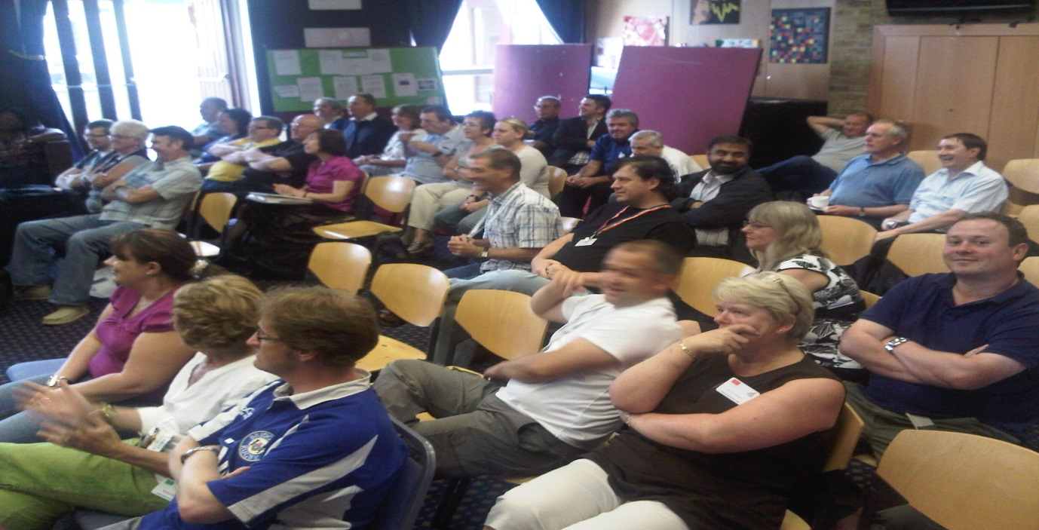
The value of listening skills

- Being Listened To

One of the most important skills for an activist is to be able to build a rapport with the people who they hope to influence. Building rapport is important, because influencing people is about persuasive communication. We judge the effectiveness of communication on the basis of whether it achieves the intended result. Research indicates that the main components of effective communication are:

- 7% - words;
- 38% - tone of voice;
- 55% - physiology.

- Words: what you say. The most significant elements are words which convey images, energy, experiences, and associations; the least influential is the content.

- Tone of voice: the way you sound. The significant elements are the tone (or pitch) of your voice, your tempo (the speed at which you speak), the timbre (the quality of your voice), and the volume.

- Physiology: the way you look or appear. The significant elements are posture and facial expression. The other elements are gesture and breathing.

So you establish rapport by means of what you say and how you say it. And the lesson to learn is that non-verbal communication is most significant: to effective communication: how you communicate has an immediate bearing upon what you communicate.

Listening Skills

Communication is a two way process. It involves not only getting our views across to other people but also listening to what they say. Most of us are not very good at listening. Even when we try, we are often thinking more about our reply rather than trying to understand what is being said to us. Active listening involves seeking to establish a rapport with the person we are talking to. We try to see what they are saying from their point of view. We need to give our full attention not only to what they say, but also how they say it and to their gestures and expressions. Besides showing interest, we need also to encourage. Asking open questions, seeking clarification as well as being sympathetic can do this.

This does not mean that you have to agree with what is said, simply that you understand the other person’s point of view. Once you understand, you can proceed with the second step: seeking to be understood. Because the other person’s need to be understood has been satisfied, we are much more likely to have influence and be understood ourselves. What this means for union organising is that we must listen to members and seek to understand them - to put ourselves in their shoes, before we seek to have them understand our view. To influence others we need to allow them to influence us, so that they know that what they are saying is not only being listened to, but a real attempt is made to understand as well.

Steps to Effective Listening

The following are key features of effective listening:
- keep calm and attentive throughout;
- show respect for what the other person is saying, even if you disagree;
- use body language which shows you are interested: lean slightly forward, maintain appropriate eye contact;
- don’t interrupt;
- establish a rapport by listening with sympathy;
clarify by asking open questions.

Public Speaking Activity

As Trade Union activists we often find ourselves in a position where we are asked to speak to a group of members. Although in presentations we can use powerpoint, flip charts or overhead projectors, in many of the members meetings we conduct we are reliant on our own skills as public speakers. Most people are wary of speaking in public, but for us it forms part of our Union role.

In this activity you will work in groups identifying the key points to consider in preparing for and delivering a speech. In conjunction with the guidance on public speaking your group will prepare a speech on a topic of your choice and at least one person will deliver the speech to the rest of the class. The speech should last for between 5 and 7 minutes. The imagined audience will be a group of individuals with little or no knowledge and understanding of the subject matter.

You have 1 hour in which to complete this exercise and prepare your speech which you will then deliver. Use the internet in order to research your subject matter if you need to do so. There may also be Unite publications and leaflets which may provide information to strengthen your case.

Although the subject matter is for you to decide it should have be connected to Unite or the broader trade union and labour movement, industrially, politically, internationally, or in the community

Top public speaking tips

- Preparation breeds success – Always prepare fully, research your subject
- Write it out – Writing your speech in full then rewriting it just summarising the key issues, then bullet pointing those issues, then jotting down key words to remind you can help when first preparing speeches
- Be yourself – Speak in your normal voice, inject your personality into the speaking
- Speak with passion – Your passion for your subject will shine through and can inspire people
- Keep it simple – Keep your message clear and simple using straightforward language and clear ideas, don’t confuse the audience with too many messages
- Understand your audience – Know who you are going to speak to, what is their likely understanding of the subject
- State and restate your message – Clearly tell them what you want them to know, tell them again and finnish by restating your message this will reinforce its importance
- Avoid jargon – do not use abbreviations or jargon unless you have explained it and made clear what you mean by it
- Dress comfortably – Ensure you feel comfortable in what you’re wearing, this will aid your confidence
- Open and close with a bang – Try and start off by saying something to wake your audience up and finish the same way. If possible link the two and remember the last thing you say wil remain in their mind
- Be animated – Be animated in the way you speak and in your body movements, use conversational style where possible, it avoids monotone droning and emphasis with your hands can stress points
- Use a comfort blanket – If you’re nervous of missing something, carry a small note with you reminding you of the key points
- Get your timings right – Practice your speech with friends or in front of a mirror and time it, also appreciate that you are likely to speak faster when you deliver the speech so allow for this.
- Check your pace and diction – Try to speak slowly and clearly, it won’t sound laboured but it will mean people hear and take in what you’re saying
- Check your venue – Ensure you check out where you are speaking, if possible check any equipment you will be using and try it out
- Hook them in – Use something topical to hook people, check to see if todays paper has a related story, reference a common TV programme or sporting event, this will connect with your audience
- Use a prop – Some people use a prop like a rolled up piece of paper or a poster to stop them not knowing what to do with their hands, it may aid nerves
- Stories are good – Injecting a good story, perhaps one with a human interest to emphasise your point will help to embed your message
- Nerves are normal – Remember nerves are totally normal and often provide the edge in speeches
- Learn from your speeches – Experience builds confidence but analyse your speeches and if possible use an honest friend to help you judge your good bits and the challenges you may have had.

